UDC …(Universal decimal classifier: http://www.udcsummary.info/php/index.php?lang=uk&pr=Y) DOI: (to be completed by the editorial office)

Name N. Surname
Academic degree, Academic title, position
Work place: identify the organization (e.g., university, department, etc.), City, Country
ORCID ID
email@email.com

Name N. Surname (for each co-author)
Academic degree, Academic title, position
Work place: identify the organization (e.g., university, department, etc.), City, Country
ORCID ID
email@email.com

ARTICLE'S TITLE IN ENGLISH

Abstract. Abstract’s text in English. Abstract should briefly and quite informative to summarize main ideas and received research results. The abstract should be at least 1800 characters long, including keywords. As search engines crawl the magazine's content by title, keyword, and annotations, as well they should describe the content of your article. To provide a better search of the content on the network, please avoid too generalized and complex language, use only well-known abbreviations.
Keywords: term 1, term 2, term 3. (from 3 to 8, divided by a comma (,) )

Прізвище Ім’я По батькові
науковий ступінь, вчене звання, посада
місце роботи: назва установи (у називному відмінку), Місто, Країна
ORCID ID
email@email.com

Прізвище Ім’я По батькові (для кожного співавтора)
науковий ступінь, вчене звання, посада
місце роботи: назва установи (у називному відмінку), Місто, Країна
ORCID ID
email@email.com

НАЗВА СТАТТІ УКРАЇНСЬКОЮ

Анотація. Анотація до статті українською мовою. Текст анотації має бути обсягом не менш як 1800 знаків українською та англійською мовами. Зміст анотації має стисло і достатньо інформативно підсумовувати основні ідеї й отримані результати дослідження, та містити відомості про кожен із розділів статті, включаючи ключові слова.
Зауважте, що дані про авторів, назва, ключові слова та анотація, будуть використані як метадані для опису Вашої статті, тому вони повинні максимально чітко описувати її зміст. Для більш якісного пошуку даного контенту в мережі Інтернет, будь ласка, уникайте занадто узагальнених і складних формулювань, використовуйте тільки загальновідомі абревіатури.
Ключові слова: поняття 1, поняття 2, поняття 3. (від 3-х до 8-ми, розділяються комою)

1. Introduction (mandatory section)
The formatting of each structural element of the article is described in the “Requirements for the formatting of articles.” These instructions have been prepared in accordance with these requirements and can be used as a template. Please check all details of the finished manuscript, including the order of authors' names, before uploading the file to the journal. Make sure that you have provided the email addresses of each author and that the pages of the article are not numbered.

2. Statement of the problem (mandatory section)
This section of the article describes the problem addressed by the study in general terms and its connection with important scientific or practical tasks.

3. Analysis of recent studies and publications (mandatory section)
This section analyzes the works that initiated the solution to this problem and on which the author relies. As a result of the analysis of sources, previously unresolved parts of the general problem to which the article is devoted are necessarily highlighted:
– references to sources are given in square brackets, for example [10];
– pages are separated by commas [3, p. 35] – 3rd source, 35th page;
– when citing several sources at once, each number must be listed separately, in its own brackets, separated by a comma or dash: [3], [4], [5], [6] or [3] – [6].

4. Research objectives and tasks (mandatory section)
Formulation of article objectives and setting of tasks.

5. Research results (mandatory section)
This section presents the concepts, approaches, principles, methods, and other provisions on which the study is directly based. It identifies the main terms, concepts, and categories underlying the study. This section contains an analysis and justification of the scientific results obtained.
It is recommended to divide it into subsections and paragraphs.
Formatting individual objects
All illustrations, program codes, and tables should be placed immediately after the text where they are first mentioned, or on the following page (not at the end of the article).
Lists
Lists are formatted as follows:
- numbering list – «1.», «1)», «a)», «VI.»;
- marking list– « – ».
Formulas
Formulas and individual mathematical symbols and letters used to denote quantities in the text should be typed in Microsoft Word's formula editor, without borders or fill. Font – Cambria Math12pt, centered alignment, numbering – in parentheses, on the right.
Leave one blank line before and after the formula.
Example:

$Q\left(s,a\right)=Q\left(s,a\right)+α(r+γ\max_{a^{'}}{Q\left(s^{'},a^{'}\right)-}Q\left(s,a\right))$ (1)

where $r$ is the reward received in epoch $t$, $γ$ is the discount factor $0<γ<1$and $α$ is the learning rate.
Program code
Program code fragments should be typed in Courier New, 9 pt. Leave one blank line before and after the code.

def nicedet(M):
s="$\\left|\\begin{array}{ccc} "
for i in range(M.nrows()):
for j in range(M.ncols()):
s=s+" "+latex(M[i,j])
if j!=M.ncols()-1:
s=s+"&"
s=s+"\\\\"
Figures
Illustrations (photographs, drawings, diagrams, graphs) should be placed in the article immediately after the text where they are first mentioned, or on the following page. All figures must be referenced in the text. Illustrations are marked with the word “Fig.” and numbered consecutively with Arabic numerals, aligned in the center. The titles of illustrations are placed after their numbers. The title of the figure is written with a capital letter and must be placed in the center of the page below the illustration. No period should be placed after the title. The quality of illustrations should ensure their clear reproduction. Illustrations in the article can be black and white or color and should have a uniform style.
One blank line should be left before the figure and after its caption.
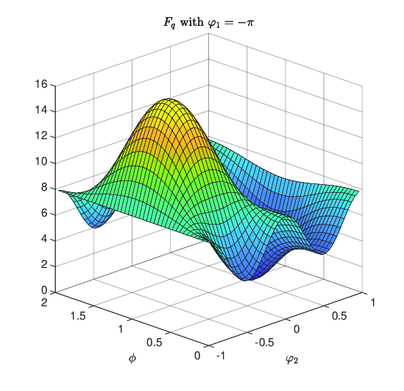
Fig. 1. Caption to the figure
Tables
Tables should be placed immediately after the text where they are first mentioned, or on the following page. Tables should be numbered, centered, and without indents. The caption «Table 1» should be aligned to the right. The table title should be centered, bold, and placed above the table. One blank line should be left before the table caption and after the table.

Table 1
Comparative analysis of reinforcement learning methods
Method name | Application | Advantages | Disadvantages | Scope of action
Q-learning | route planning, obstacle avoidance, learning optimal strategies under uncertainty | easy to implement | high computational cost | discrete
DQN | interaction with objects and obstacles | effective in uncertain conditions | prone to overestimating Q-values | discrete
…

6. Conclusions and prospects for further research (mandatory section)
This section briefly summarizes the results of the research presented in the main part and necessarily indicates directions for further research.

Authors' contributions (required if there is more than one author). First name Last name – conceptualization; methodology; First name Last name – software; First name Last name – collection and verification of empirical data; First name Last name – empirical research; First name Last name – analysis of sources, preparation of a literature review or theoretical basis of the research.

Acknowledgements, funding sources (optional section)
In this section, you can list organizations (research institutions, universities, departments, sponsoring organizations, etc.) and individuals who contributed to improving the quality of the content or provided financial support for the research presented in this article.
Indicate the source of funding, if available. Recommended format: “This work was supported by the Medical Research Council (grant number xxxx).” If there was no specific funding, do not include this section.

Declaration on artificial intelligence (mandatory section)
Indicate whether artificial intelligence was used; if so, for what purposes and for which structural elements of the article.

Conflict of interest (mandatory section)
The author declares that there is no conflict of interest and confirms that during the preparation of this work there were no commercial, financial, or other relationships that could be construed as influencing the results of the study or their interpretation. The work was performed in accordance with the principles of academic integrity, ethical standards for conducting scientific research, and editorial policy requirements for preventing conflicts of interest.

References

Sources should be formatted according to the APA standard: https://www.grafiati.com/
There should be at least 10 sources.
At least 60% of the references should be to foreign sources.
The percentage of self-citations should not exceed 20%.
We recommend that the list of references contain no more than 30 titles.

Received: 01.01.26
Revised: __.__.26
Accepted: __.__.26

MINIMUM ARTICLE LENGTH 8 PAGES

